Oxton St Saviour’s CE Primary School - Virtual Sports Day Challenge
Monday 18th May – Monday 8th June 2020

Hi children,
I know how much we all look forward to our annual Sports Day and we do not want 2020 to be any different! With the help of Mr Sheehan, there are some challenges that have been designed for you to complete at home. You can complete as many of the challenges as you like and as many times as you like. For each challenge you complete, please record your top score or time on the results sheet and then by using the ‘Medal Charts’ for your year group you can find the medal you achieved for each activity and the number of points this awards you. Once you have completed as many of the challenges as you wish, calculate your total number of points. Send your completed results form to newsletter@oxtonstsaviours.wirral.sch.uk by Monday 8th June and I will total all of the scores to find out who the winning House Team is for 2020. If your child cannot remember what house they are in here is a reminder of the colours:
Red – Fire
Green – Earth
Blue – Water
Yellow – Air
With the help of Mr Sheehan (and our school’s Sports Ambassadors, Lily and Charlie), a short video has been created to demonstrate each challenge to help. If you cannot access the video on your email, please look in the gallery section on the school website to watch.
We would love to see you all taking part so please send in any photos or videos of you completing the challenges to newsletter@oxtonstsaviours.wirral.sch.uk so we can create a video to celebrate your achievements.
It would be great if you could take part in the ‘Sports Day Challenges’ wearing your school PE kit
Have fun and good luck!

Miss Gerrard
PE Leader

Challenges

- Map my run
Run or walk a set distance – use free app ‘Map My Run’ to record distance. Record your furthest distance in km and m.

- Bottle Flip
How many times can you flip a bottle to land in one minute?

- Toilet Roll Speed Bounce
Place 2 toilet rolls in a row. Count the number of times you can jump over the toilet rolls.
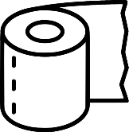
Year 3&4 - 20 seconds
Year 5&6 - 30 seconds

- Sock Throw
You have 10 attempts to throw a pair of rolled up socks into a saucepan. Record the number of times the socks land in the pan.
Year 3&4 - Place a saucepan 3 steps away.
Year 5&6 – Place a saucepan 5 steps away.

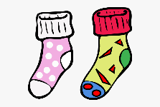
- Toilet Roll Balance
Stand on 1 leg and place a toilet roll on your head. Time yourself until the toilet roll falls off or your leg/foot touches the floor. Record your best time.

- Toilet Roll Plank Balance
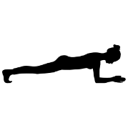
In the plank position, place a toilet roll on the middle of your back. Hold the position until the toilet roll falls or your tummy touches floor. Record your best time.

- Sock and Spoon
Using a rolled pair of socks and spoon, perform a figure of 8 between your legs. The spoon must change hands as it passes through your legs. If socks fall, carry on as quickly as you can. Record the total number of figure of 8s completed in 1 minute.
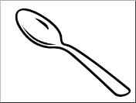

- Wall Squat
With your back against a wall, bend your knees to a 90-degree angle (right angle). Hold the position for as long as you can. Record your best time.
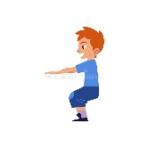

Results
Name………………………………………………. Class…………………………….. House……………………………
Challenge | Distance/Time/Score | Medal | Points
Map My Run
Bottle Flip
Toilet Roll Speed Bounce
Sock Throw
Toilet Roll Balance
Toilet Roll Plank Balance
Sock and Spoon
Wall Squat
Total Points

Y3&4 Medal Chart
Challenge | Bronze Medal  (3 points) | Silver Medal  (5 points) | Gold Medal  (10 points)
Map My Run | 0-1km | 1km-2km | 2km+
Bottle Flip | 0-1 | 2-4 | 5+
Toilet Roll Speed Bounce | 0-15 | 16-29 | 30+
Sock Throw | 0-1 | 2-4 | 5+
Toilet Roll Balance | 0-15 seconds | 16-29 seconds | 30 seconds+
Toilet Roll Plank Balance | 0-1 minute | Up to 2 minutes | 2 minutes +
Sock and Spoon | 0-8 | 9-14 | 15+
Wall Squat | 0-30 seconds | 31-59 seconds | 1 minute+

Y5&6 Medal Chart
Challenge | Bronze Medal  (3 points) | Silver Medal  (5 points) | Gold Medal  (10 points)
Map My Run | 0-1.5km | 1.5-3km | 3km+
Bottle Flip | 0-1 | 2-4 | 5+
Toilet Roll Speed Bounce | 0-30 | 31-59 | 60+
Sock Throw | 0-1 | 2-4 | 5+
Toilet Roll Balance | 0-30 seconds | 31-59 seconds | 60+ seconds
Toilet Roll Plank Balance | 0-1 minute | Up to 2 minutes | 2 minutes +
Sock and Spoon | 0-8 | 9-14 | 15+
Wall Squat | 0-30 seconds | 31-59 seconds | 1 minute+

