
Oxton St Saviour’s CE Aided Primary School
Holm Lane

Oxton, Prenton
Merseyside CH43 2HT

Headteacher: Mr A Ramsden (B.Ed. Hons NPQH)

WELCOME TO OUR OUT OF SCHOOL CLUB

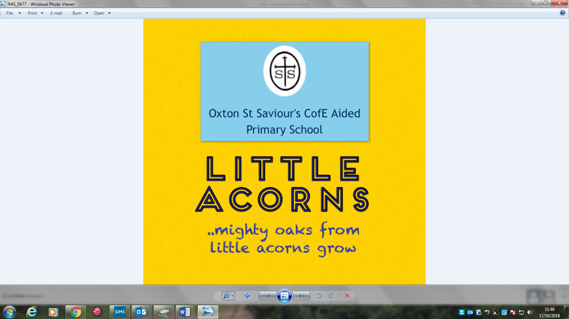


Come and have fun at Little Acorn’s! We are here to play from
7.45am -9am & 3.15pm – 5.45pm *every school day
(updated September 2022)

Our before and after school club is set up and managed by the Headteacher and the Governing Board of the school. All policies that relate to the school apply to these settings to continue the values and ethos of the school. It is available to all Oxton St Saviours CE (Aided) Primary School pupils from Foundation Class to Year 6 during term time only excluding INSET days. Our dedicated, qualified staff are here to care for your child and ensure that they are happy and having fun. There are a wide range of activities to take part in including craft activities, organised group games and a wide range of resources to play with.

AM session 7.45am-9.00am (£4.50) ~ PM session 3.30pm–5.45pm (£8.50)

*On the last day of each term (Christmas, Easter and Summer) school closes at 2.00pm. On these dates Little Acorns closes at 4.15pm.
From September 2022 bookings can no longer be made via Miss Latters on the club’s mobile phone. Parents must book their child's place direct on ParentPay providing they have credit in their account and they book in advance.

Please find attached to the back of this registration form some FAQ's to assist you!

Oxton St Saviour’s CE (Aided) Primary School

REGISTRATION FORM

LITTLE ACORNS – OUT OF SCHOOL CLUB

Please complete for each child

NAME OF CHILD
AGE |  | DATE OF BIRTH
CLASS |  | TEACHER
PERSON(S) AUTHORISED TO COLLECT CHILD
NAME |  |  | TEL No
NAME |  |  | TEL No
NAME |  |  | TEL No

Does your child have additional support needs? Will you be paying with childcare
vouchers/HMRC TFC scheme?
YES / NO (please delete as appropriate)
YES / NO (if yes please state provider)
If yes, please provide details:

PLEASE INDICATE BELOW WHICH DAYS OF THE WEEK YOU REQUIRE PLACES

 | Monday | Tuesday | Wednesday | Thursday | Friday
Breakfast Club

After School

Please state who has:

Parental responsibility for the child: ……………..………………………………………………………………………………….

Legal contact with the child: ……………………………………………………………………………………………………….……

Signed ………………………………………………………………… Relationship to child…….…………….……………………….

Print name: ………………………………………………….………………. Date: …………………………………………………………

WELCOME TO

LITTLE ACORNS FAMILY MEMBERSHIP & PAYMENT DECLARATION FORM

NAME OF FAMILY
NAME OF CHILD(REN) ATTENDING | NAME DOB
NAME OF CHILD(REN) ATTENDING | NAME DOB
NAME OF CHILD(REN) ATTENDING | NAME DOB
ADDRESS
TELEPHONE NUMBER (MOBILE)

TELEPHONE NUMBER (DAY & EVENING)

EMAIL ADDRESS

Payment Agreement

I understand that with effect from September 2022, I will have to book and pay for my child’ place (or amend/cancel existing bookings) in advance as per the deadline date/time stated above.

Signed ………………………………………………………………………………………………………………………………

Print Name ……………………………………………………………………………………………………………………………

Date ……………………………………………………………………………………………………………..……………………

EMERGENCY CONTACTS FORM

EMERGENCY CONTACTS (in order of priority)

- NAME …………………………………………………………………………………………………………………………..……………………

MOBILE NIMBER …………………………………………………………………………………………………………………………..…..

WORK NUMBER …………………………………………………………………………………..……………………………………………

RELATIONSHIP TO CHILD ………………………………………………………………………………………………………….……….

- NAME …………………………………………………………………………………………………………………………..……………………

MOBILE NIMBER …………………………………………………………………………………………………………………………..…..

WORK NUMBER …………………………………………………………………………………..……………………………………………

RELATIONSHIP TO CHILD ………………………………………………………………………………………………………….……….

- NAME …………………………………………………………………………………………………………………………..……………………

MOBILE NIMBER …………………………………………………………………………………………………………………………..…..

WORK NUMBER …………………………………………………………………………………..……………………………………………

RELATIONSHIP TO CHILD ………………………………………………………………………………………………………….……….

MEDICAL INFORMATION FORM

CHILD’S NAME ………………………………………………………………………… DATE OF BIRTH …………………………………

NAME OF DOCTOR ………………………………………………………………………… TEL No ………………………………………

DOCTORS ADDRESS ……………………………………………………………………………………………………………………………..

- Does your child suffer from any medical condition that could require expert medical attention? YES/NO (if yes please provide further details)

…………………………………………………………………………………………………………………………………………………………

……………………………………………………………………………………………………………………………………………………..….

- Does your child have any allergies or reactions to food/drink/medicines (including natural remedies) YES/NO (if yes please provide further details)

………………………………………………………………………………………………………………………………………………………

……………………………………………………………………………………………………………………………………………….……..

- Does your child have any special dietary requirements? YES/NO (if yes please provide further details)

……………………………………………………………………………………………………………………………………………………….

……………………………………………………………………………………………………………………………………………………….

- Does your child have any special needs? YES/NO (if yes please provide further details)

……………………………………………………………………………………………………………………………………………………..…

………………………………………………………………………………………………………………………………………………………...

- Are there any other circumstances that could affect your child’s participation in activities?

…………………………………………………………………………………………………………………………………………………………..

…………………………………………………………………………………………………………………………………………………………..

MEDICAL TREATMENT DECLARATION: I being parent/carer of the above named child hereby give my permission for Oxton St Saviour’s After School Club (Little Acorns) to give immediate necessary authority on my behalf for any medical or surgical treatment recommended by competent medical authorities, where it would be contrary to my child’s interest, in the doctors medical opinion, for any delay to be incurred by seeking my personal consent. I declare that the answers to the above questions are true, that I have not withheld any relevant information.

Signed……………………………………………………………… Print Name ………….………………………….………………… Date ……………..………

Little Acorns FAQ’s
Is there a deadline for bookings/amendments? Yes. All bookings and changes must be made by 4.30 pm each Friday for each new week. For example, if you need to book or cancel your child's place for Monday morning (i.e. Mon 6th June) and you attempt to do this on-line on Saturday evening (Sat 4th June), then you will not be able to make this booking. The reason for this deadline is to ensure the club is adequately staffed and resourced for the week ahead.
How far in advance can I book my child's place? 100 days is the maximum. Parents can choose to book a week ahead, a month, half-termly or termly. As long as there is credit in the account, parents can make bookings.

How to book a place?
1. Log into ParentPay and select the child you wish to make a booking for
2. Select ‘make or view’ bookings
3. Select the session i.e. ‘morning club’ or ‘afterschool club’
4. Select the days you want to book (a summary will be appear bottom of the page)
5. Review the booking summary and select ‘confirm booking’
6. Repeat the process if you would also like to book an ‘afterschool’ session
All bookings must be confirmed and paid for within 2 hours of selecting them - failure to do so will result in the bookings being automatically cancelled.
Do school accept Childcare Vouchers & HMCR TFC payments (tax free childcare)?
Yes. We accept payments from the following childcare voucher providers; Edenred, Fideliti, Bravo Benefits, Computershare, Kiddivouchers and Care-4. If you are registered with a childcare voucher provider, once you make a payment to them, they will send the school office confirmation of this payment. Upon receipt of this notification the school office will then 'credit' the pupil's account as close as reasonably possible to receiving the remittance/notification. If you pay via the HMRC TFC scheme your payment will only be processed if you inform Mrs Mulla office@oxtonstsaviours.wirral.sch.uk with the date of payment and the amount. This is because unfortunately the HMRC scheme do not send receipts to schools.
Please bear in mind that the school office is closed during school holidays, so if voucher or TFC payments are made during the holidays, your account will not be credited until school re-opens. Planning ahead and being in credit at all times is key to ensuring you can book at any time!

What if I miss the deadline and need to book in an emergency? We understand that in emergencies late appointments will be required. Please contact the school office in these urgent circumstances on 652-4909 or on 0745894484. Swops, changes or forgetting to book are not considered emergencies and bookings will not be taken in these instances.

What food is provided during the sessions? AM session: Cereals, toast, crumpets, jams and fresh fruit, water, milk PM session: Sandwiches, hot dogs, pancakes, crackers and fresh fruit, water, milk.

